On your mark….
- Each team gets 1 car.
- How far the car moves forward depends on how far it gets pulled back
- The challenge is to get your team's car to go a certain distance (reach the finish line) without going over. This distance is not revealed until later.
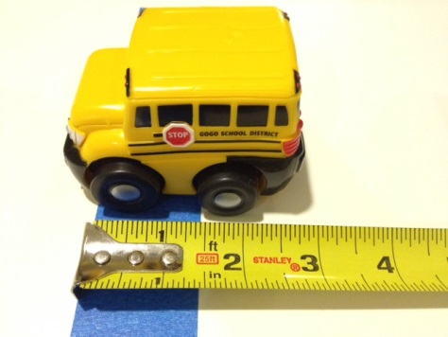
- To predict how much pull-back your car needs to go a certain distance, "test drive" your cars for pull-backs of 2, 4, 6, and 8 inches. Do three trials for each distance (these cars can be finicky).

Get set…
- Take measurements from the car's front wheels.
- The blue tape marks the starting line. Front wheels line up at the front of the tape.

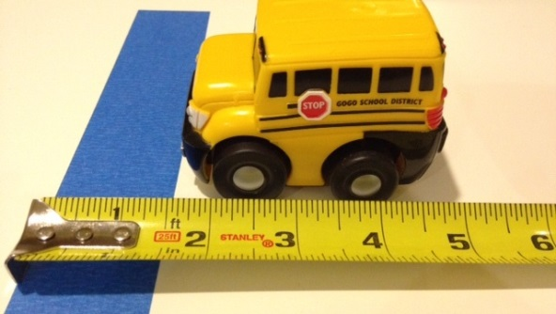
- The car is then pulled back a certain distance — here it's 2 inches — and let go.

- When the car stops, the distance traveled is measured from front of wheels to front of blue tape. Looks about 13.2 inches here.
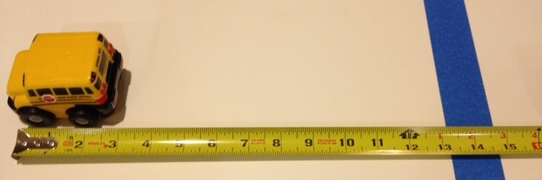
Go!
- Each member of the group should record and graph the data. Find an equation which models the data.
- After I reveal the distance, each group will get one chance to win. The car which comes closest to the farthest edge of the finish line, without going over, wins.

