I recently went to the store to purchase light bulbs. The options were a bit overwhelming. Do I buy standard bulbs (incandescent) or energy efficient ones? If I buy energy efficient ones, which kind: LED or Compact Florescent (CFL)?
Below are the best-looking options to me from Home Depot’s website. Make a decision about which bulb is most cost-effective over the life of the bulb and which bulb you suggest purchasing using math to explain your reasoning.
Incandescent:
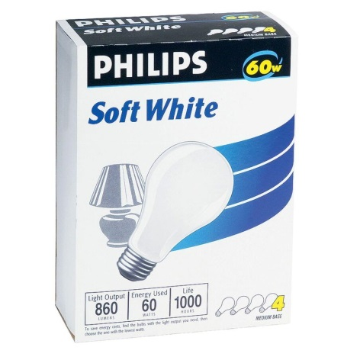  Philips 60-Watt Household Incandescent Light Bulb (4-Pack) | 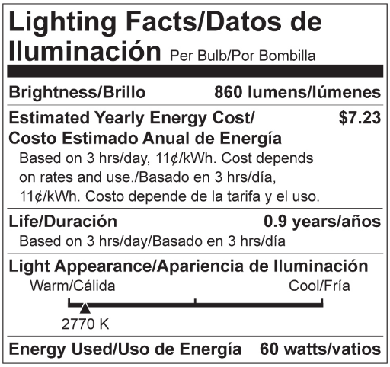  Average Life: 1000 hours | $1.47 / package
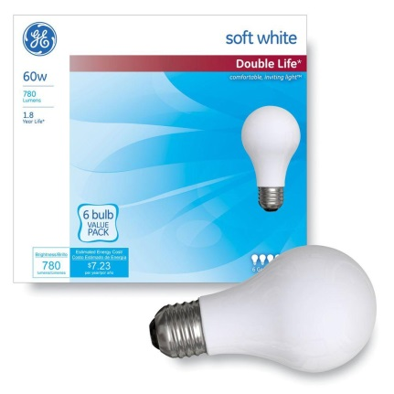  GE Double Life 60-Watt A19 Soft White General Purpose Incandescent Light Bulb (6-Pack) | 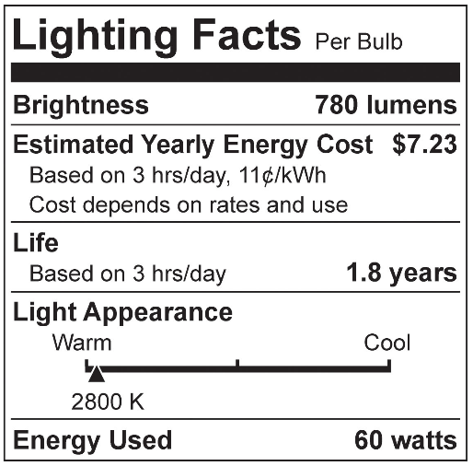  Average life: 2000 hours | $3.97 / package

LED
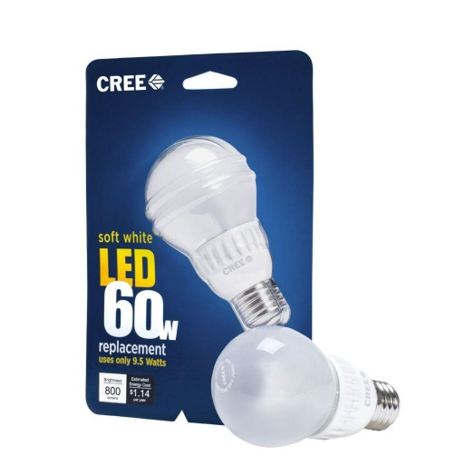Cree 9.5-Watt (60W) Soft White (2700k) Dimmable LED Light Bulb (E) | - Brightness: 800 Lumens  - Estimated yearly energy cost: $1.14 (based on 3 hours per day, 11 cents kWh. costs depend on rates and use)  - Life: 22.8 years (based on 3 hours per day)  - Light appearance: 2700K (soft white)  - Energy used: 9.5 Watts (equivalent to a 60 watt standard incandescent light bulb)  - Lumens per Watt: 84  - Dimmable: yes  - Lights instantly, omni-directional | $12.97 / each
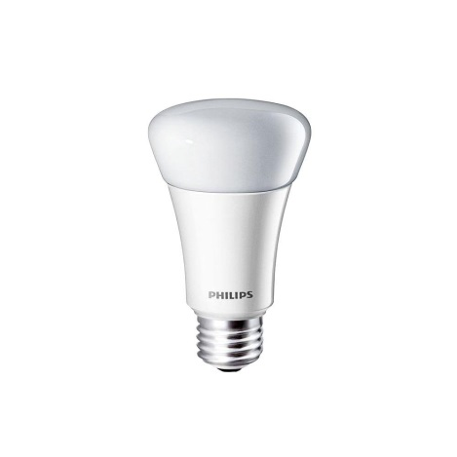Philips 11-Watt (60W) A19 Household Soft White (2700K) Dimmable LED Light Bulb (2-Pack) | - Brightness: 830 lumens  - Estimated yearly energy cost: $1.32 (based on 3 hours per day, 11c/kwh. costs depend on rates and use)  - Life hours: 22.8 years (based on 3 hours/day)  - Light appearance: 2700K (soft white)  - Energy used: 11 Watts (equivalent to a 60-Watt standard incandescent light bulb)  - Lumens per Watt: 76  - Dimmable: yes | $29.94 / case

Compact Floursescent (CFL)
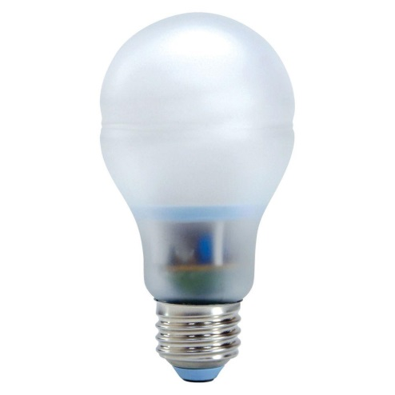  GE Reveal 15-Watt (60W) Bright from the Start CFL Light Bulb (2-Pack) | - Light output: 740 lumens  - Energy used: 15-Watts  - Life hours: 8,000 hours  - Lasts 7.3 years based on 3 hours per day usage  - Estimated yearly energy costs $1.81 based on 3 hours per day $0.11 per kWh  - A19 shape with medium base for use in table lamps and enclosed fixtures  - 2500K soft white light appearance  - Contains mercury: Y  - 2 bulbs per package | $13.97 / each
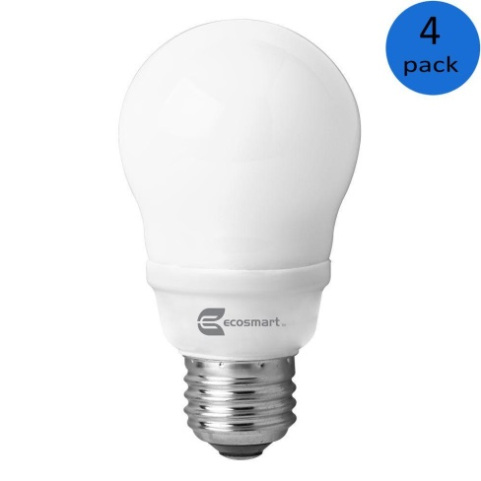  EcoSmart 14-Watt (60W) A19 Bright White CFL Light Bulb (4-Pack) | - Brightness: 800 lumens  - Estimated yearly energy cost: $1.69 (based on 3 hours per day, 11¢/kWh. costs depend on rates and use)  - Life hours: 7.3 years  - Light appearance: 3500K (bright white)  - Energy used: 14-Watt (equivalent to a 60-Watt standard incandescent light bulb)  - Lumens per Watt: 57  - Contains mercury: Y (for more on clean-up and safe disposal visit: epa.gov/cfl)  - Dimmable: N | $15.94 / each

