Introduction:
Equality is something we all hold dear. No one wants to be treated unfairly or taken advantage of. In the last 150 years, the United States has seen a dramatic change in how it values women. Women have gained the right to vote, the right to own property, and access to the workplace. Women were even granted the right to a fair wage under the Equal Pay Act of 1963. But the fight for equality has not been easy nor does it seem to be over. With the defeated Fair Pay Act of 1999 and the proposed pay equity legislation in 2000, apparently some people still think they are being treated unjustly. But is there really a problem? If there is a problem, how big is it? Together we are going to try to find an answer to those questions.

The following table includes median incomes in the United States for full-time year-round workers (all races) from 1955 to 2003 by gender.

Year Male Female Year Male Female
2003 | 41,503 | 31,653
2002 | 40,507 | 30,970
2001 | 40,136 | 30,420
2000 | 38,891 | 29,123
1999 | 37,574 | 27,370
1998 | 36,252 | 26,855
1997 | 35,248 | 26,029
1996 | 33,538 | 24,935
1995 | 32,199 | 23,777
1994 | 31,612 | 23,265
1993 | 31,077 | 22,469
1992 | 30,832 | 22,093
1991 | 30,331 | 21,245
1990 | 28,979 | 20,591
1989 | 28,419 | 19,638
1988 | 27,342 | 18,545
1987 | 26,681 | 17,564
1986 | 25,894 | 16,843
1985 | 24,999 | 16,252
1984 | 24,004 | 15,422
1983 | 22,508 | 14,479
1982 | 21,655 | 13,663
1981 | 20,692 | 12,457
1980 | 19,173 | 11,591
1979 | 17,479 | 10,531
1978 | 16,062 | 9,641
1977 | 15,070 | 8,814
1976 | 13,859 | 8,312
1975 | 12,934 | 7,719
1974 | 12,162 | 7,174
1973 | 11,468 | 6,488
1972 | 10,538 | 6,053
1971 | 9,631 | 5,701
1970 | 9,184 | 5,440
1969 | 8,668 | 5,077
1968 | 7,814 | 4,568
1967 | 7,289 | 4,198
1966 | 6,955 | 4,026
1965 | 6,598 | 3,816
1964 | 6,284 | 3,710
1963 | 6,070 | 3,556
1962 | 5,826 | 3,457
1961 | 5,663 | 3,341
1960 | 5,434 | 3,296
1959 | 5,241 | 3,206
1958 | 4,949 | 3,101
1957 | 4,722 | 3,007
1956 | 4,467 | 2,829
1955 | 4,241 | 2,735

Source: US Census Bureau Current Population Survey 2015. The data can be found at the link http://www.census.gov/data/tables/time-series/demo/income-poverty/historical-income-people.html as of 2015

Task 1: Equations from Tables and Graphs
- In your groups, find lines of best fit and their equations for both the median Men’s and Women’s incomes. Be sure to include either work or an explanation of how you found your line.

Using the context of ‘Women’s and Men’s median incomes’, what does the number for slope stand for in real life?

What does the ‘y-intercept’ stand for in this situation?

- Lines of best-fit can be very useful in helping us estimate what might happen to the data over time. With your equation, use tables, graphs, or symbols to estimate the median income for both Women and Men in the years:
Year | 1963 | 1983 | 2023 | 2053
Women’s Incomes

Men’s Incomes

- As a class, compare your estimates for the Median incomes of Women and Men. Are they the same? If not, what might account for the differences?

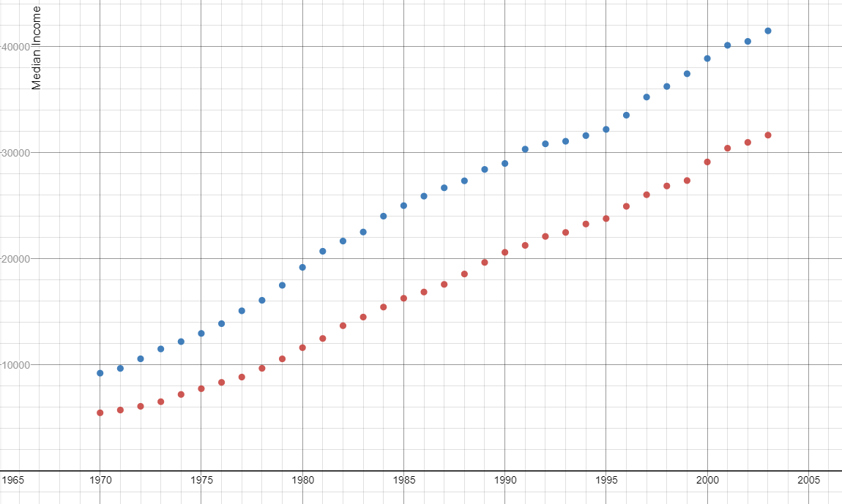
Median Incomes from 1970 to 2003
Task 2: Linear Regression
In the previous task we each guessed at a line we thought came close to all the data. We then used those lines to estimate the median incomes for Men and Women several years into the future. However, we have a problem. If we are going to estimate incomes, we all want to come up with estimates that are close to each other. To do this, we have to agree on how we are going to find our trend lines. The mathematical community ran into this problem years ago and adopted a process called linear regression. The idea behind linear regression is to minimize all of the individual errors between our made-up trend line and the real data values. This can be a very time-consuming process to do by hand; thankfully our calculators and computers can do all of the calculations for us. For TI-83 graphing calculators, once we have our data in the lists, we follow these steps: STAT CALC LinReg(ax+b) L1, L2.

- Using the median incomes for Men and Women starting in 1970, create two linear regression lines: one for Women and one for Men.

Men: Women:

What is your ‘r’ value and what does it tell you about your regression equation?

- Using your regression equations:
  - Estimate the median incomes for Women and Men in the years:
Year | 1963 | 1983 | 2023 | 2053
Men’s Incomes

Women’s Incomes

- What do your equations suggest about the relationship between incomes for Women and Men in the United States?

- The current Census statistics say the Median income in 2015 for Men was $52,247 and for Women was $41,754. How accurate is your equation?

Task 3: Cents For Every Dollar (Ratios)
- Often in news reports about the gender pay gap the term ‘cents for every dollar’ is used. For example, in the year 2001, women earned fewer than 76 cents for every dollar men earned. This idea of ‘cents for every dollar’ offers some new insights into our problem. To help us see any possible patterns we will use a table to organize our information.
a) Use the original data to fill in the following table.
Year | Cents earned by women for every dollar earned by men.
1970
1975
1980
1985
1990
1995
2000

b) What patterns do you see in the table?

- On the following page is a scatterplot of the ratio of women’s to men’s median incomes from the years 1970 to 2003. Create an equation for the ratios of Women’s to Men’s Median Incomes and graph the equation on the scatterplot.

- Using your equation, what are the estimated ratios for Women's to Men's incomes in the years?
Year | 1963 | 1983 | 2023 | 2053
Ratio of Incomes (w/m)

- What would a value above 1 mean in this situation?

- Taking into account what we have previously found out about the relationship between median incomes for Women and Men, what problem have we just encountered?

- Our estimate for the Women’s to Men’s Income Ratio in 2053 is causing a problem. Let’s check it by using our regression equations for Women and Men’s incomes. In task 2 you found equations for median incomes for both Women and Men and calculated the estimates for median incomes in 2053. Use those estimates to find the estimated income ratio for Women to Men in 2053.

- How does this ratio for 2053 compare to the previous ratio for 2053? Why is this happening?

- Fill in the following table to help correct our estimates of Women’s to Men’s income ratios.
Year | Estimated Median Income for Women | Estimated Median Income for Men | Estimated Ratio of Women’s to Men’s Incomes
1983
2003
2023
2043
2053

- Look back at the scatterplot for the ratio of Women’s to Men’s incomes (#2). Use the table you just created to draw in what the estimated distribution should look like.

