- Build each of the following polyhedron out of Magformers. For each shape, determine the number of faces, edges, and vertices. Record your results below.
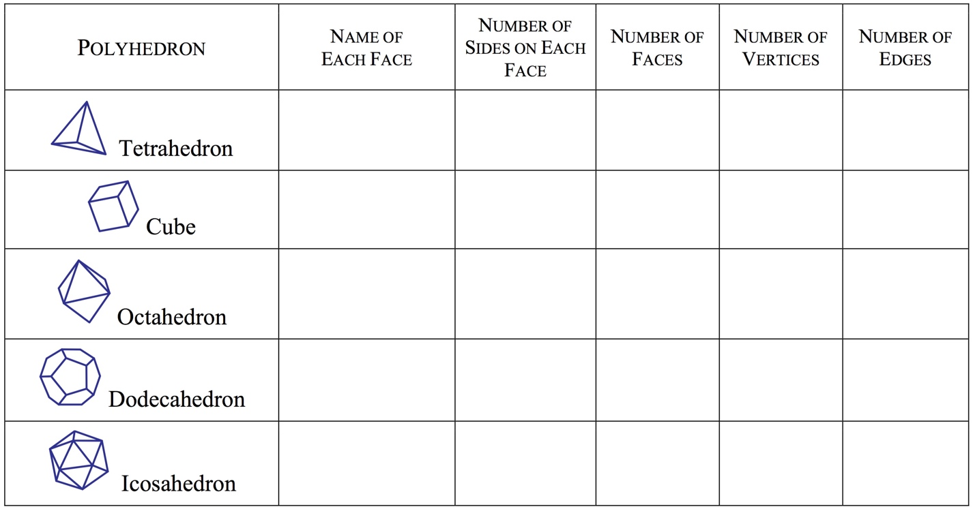

- Looking at the Tetrahedron, what relationship(s) do you see between the number of faces, vertices and edges? Use the space below to document your though process.

- Find a relationship between the number of faces, vertices and edges which holds for all of the polyhedron in the table. (Note: Swiss mathematician Leonhard Euler (1707–1783) discovered a formula that relates these quantities.)

- Draw a polyhedron not in the table above. Does the relationship from number 3 work for your new shape as well? Why or why not?

- Pick three of the solids from the table and draw nets for them.
  - b. c.

- Find the surface area for the three shapes you drew nets for in the previous question.
  - b. c.

