Geometry
17c Exploring Trigonometric Functions

Given the unit circle AB with line EF tangent to the circle at point C and central angle BAC, the length of each of the following segments represents one of the six trigonometric ratios (sine, cosine, tangent, cotangent, secant, and cosecant). State the ratio represented by each segment and explain how you know.

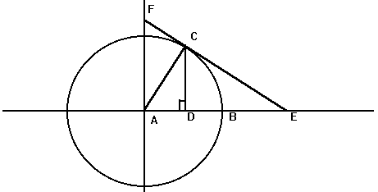

1) Segment AD

2) Segment AF

3) Segment AE

4) Segment CD

5) Segment CF

6) Segment CE

Adapted from the Holt High School Mathematics Department

