Directions
Use graph paper to create your own design with at least 8 colored regions. You need to write the inequalities for each region and should use at least 4 lines that are not vertical and not horizontal. Remember to include some dashed lines as well.

Check your design inequalities using Desmos.
First, a couple of Desmos pointers. To get a less than or equal to symbol ( i.e. $≤$ ) you would first type in a less-than symbol and then an equal to symbol Desmos will automatically change it to less than or equal to. [ < = $≤$ ]
To restrict the domain in Desmos you need to add brackets { } and an inequality telling Desmos what x-values you would like to use.

For example, here’s the graph of y < x+3:
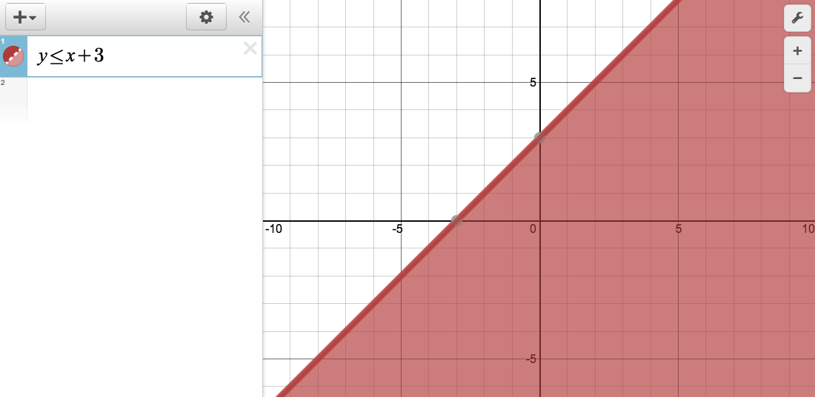

To just fill in the part of the graph between -5 and 2 inclusive you would type in:
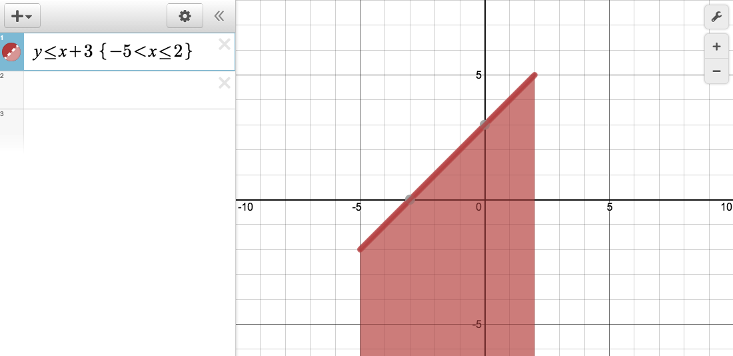

To create a triangular shape, you need to add a lower boundary at y=2. We want everything above y=2, namely y > -2. To do this, create a compound inequality:
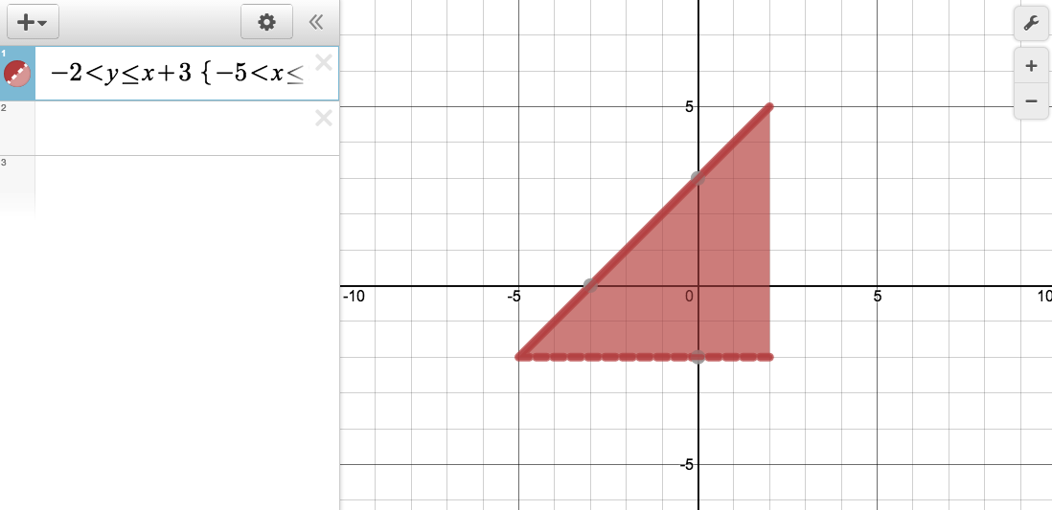
Notice the dashed line at y = 2. In order to get a solid line you would need to use -2 is less-than or equal to.

