A circular tile is placed at the center of the patio. Then a ring of tiles is made around the first tile so that all of the tiles are touching. Each subsequent ring is made around the preceding ring the same way. The numbers shown tell to which ring that tile belongs.
You may choose to either 1) make a tile pattern using round markers through the sixth ring or 2) draw the tile pattern through the sixth ring below. Be sure to record your data in the table.
How many tiles are needed for a patio with 15 rings?

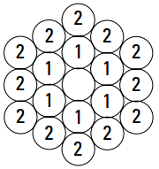

n = the number of the ring | 1 | 2 | 3 | 4 | 5 | 6
C(n) = the total number of tiles used in a patio with n rings

Half of a rectangular tile is placed at the center of the patio. Then a ring of full tiles is made around the first tile as shown. Subsequent rings continue this pattern. The numbers shown in the diagram tell to which ring that tile belongs.
You may choose to either 1) make a tile pattern using dominoes through the sixth ring or 2) draw the tile pattern through the sixth ring below. Be sure to record your data in the table.
How many tiles are needed for a patio with 15 rings?

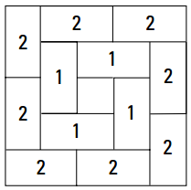

n = the number of the ring | 1 | 2 | 3 | 4 | 5 | 6
R(n) = the total number of tiles used in a patio with n rings

