Situation 1:
- Open up the Desmos page with the data.

- Using what your learned from the snowboard quadratic lesson, create an equation in vertex-form, $y=a{(x-h)}^{2}+k$, that models the data.
  - Work/explanation to find ‘h’ and ‘k’?

  - Work explanation on finding ‘a’.

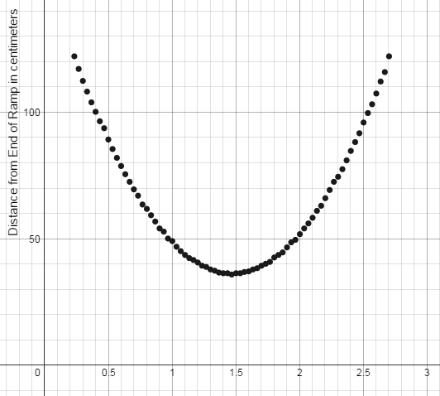

- Be sure to include all of your work, including either a screenshot or a printed page of your graph working in Desmos.

Situation 2:
In this situation, the graph is a little messier.
1) Open up the Desmos page with the data.
2) Create an equation in vertex-form, $y=a{(x-h)}^{2}+k$, modeling the data.
- Work/explanation finding ‘h’ and ‘k’.

- Find ‘a’ without using sliders or guess and check. Be sure to show your work.

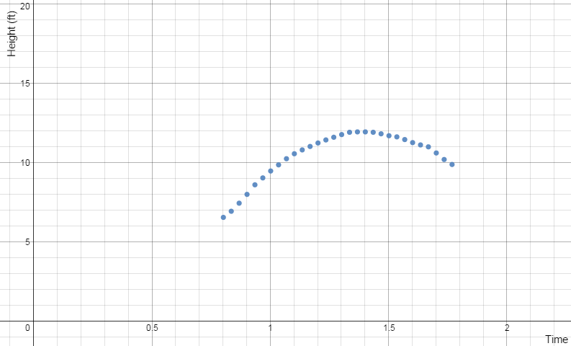
3) Be sure to include all of your work, including either a screenshot or a printed page of your graph working in Desmos.

Practice:
Write the quadratic equation, in vertex form for each graph. The parent function is the dashed line graph of y = x². Hint: It helps to find where the five new points are on the transformed graph.
1)
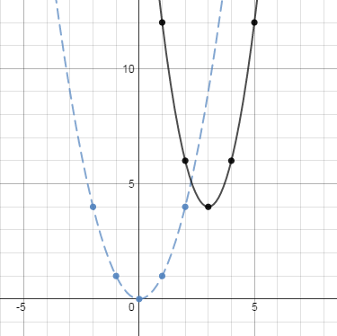
2)
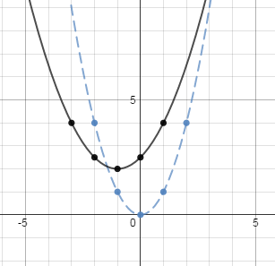

3)
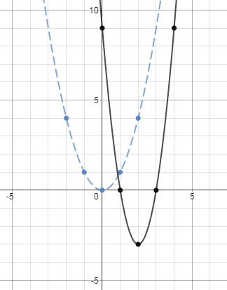
4)
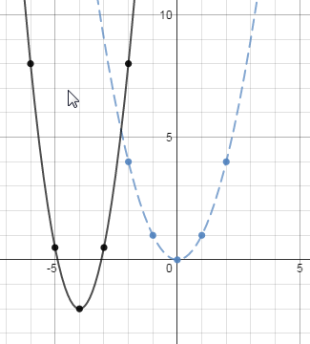

For the following problems, use the table to find an equation in vertex form: $y=a{(x-h)}^{2}+k$.
x | 1 | 2 | 3 | 4 | 5
y | 8 | 5 | 4 | 5 | 8
5)

x | 2 | 3 | 4 | 5 | 6
y | 17 | 8 | 5 | 8 | 17
6)

x | -10 | -9 | -8 | -7 | -6
y | 28 | 13 | 4 | 1 | 4
7)

Challenge Problems:
8)
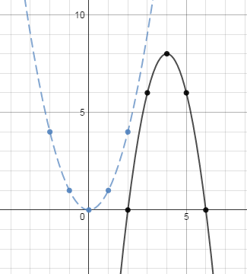

x | -3 | -2 | -1 | 0 | 1
y | -6 | -1 | 14 | 39 | 74
9)

