Geometry
17g: Track Problem

Fielding Nair International (FNI), the company renovating our school, is also contracted to build new tracks at several of the Boulder Valley area schools. BVSD wants FNI to plan and construct new tracks that meets the criteria of the NCAA. The track will consist of two straight sections and two semicircle curves. Although FNI’s blueprints contain the dimensions of the track, they are still in need of assistance on some crucial aspects of the track design.

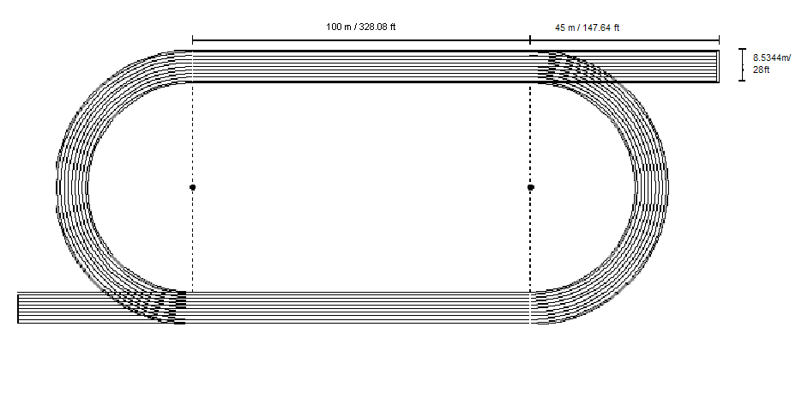Drawing is not to scale.
- Why do the starting marks need to be staggered?

- The track being built will consist of a 400m track with 8 lanes. Each lane is 3.5 ft (approximately 1.0668 m) wide. You need to decide where the starting position should be for the 400m event. The finish line for all races will be at the end of the straight away on the audience’s side. The 400 meters is measured on the inside lane of the track at a distance of 8 inches (approximately .2032 m) from the inside line that separates the lanes. Give precise directions that a sports official could easily follow. When placing the starting positions, keep the audience’s view in mind.

- Calculate the surface area of the entire surface of the track including the extensions.

- The following diagram shows which materials will be placed underneath the track to prevent it from cracking during the winter and for drainage. Compute how much of each material will be required for the construction. U.S. Tons are the industry’s standard units for such quantities. You should report the necessary amount of each material in these units. You will need the densities shown in the table to make calculations. Finally, the inside of the track is intended to be used as a football/soccer field and should therefore be a grassy area. Compute how much sod (in square yards) you would have to order to cover the inside area of the track.
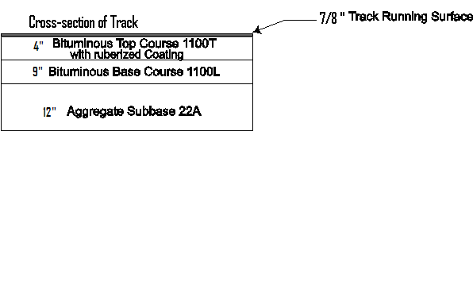

Material | Density ⁻¹ (cubic yards/ton)
Rubberized Track Surface | 1.979
Bituminous base 1100T | 0.534
Bituminous Base 1100L | 0.521
Aggregate Sub-base | 0.623

Adapted from Holt High School Mathematics Department
